**Task No 1:**

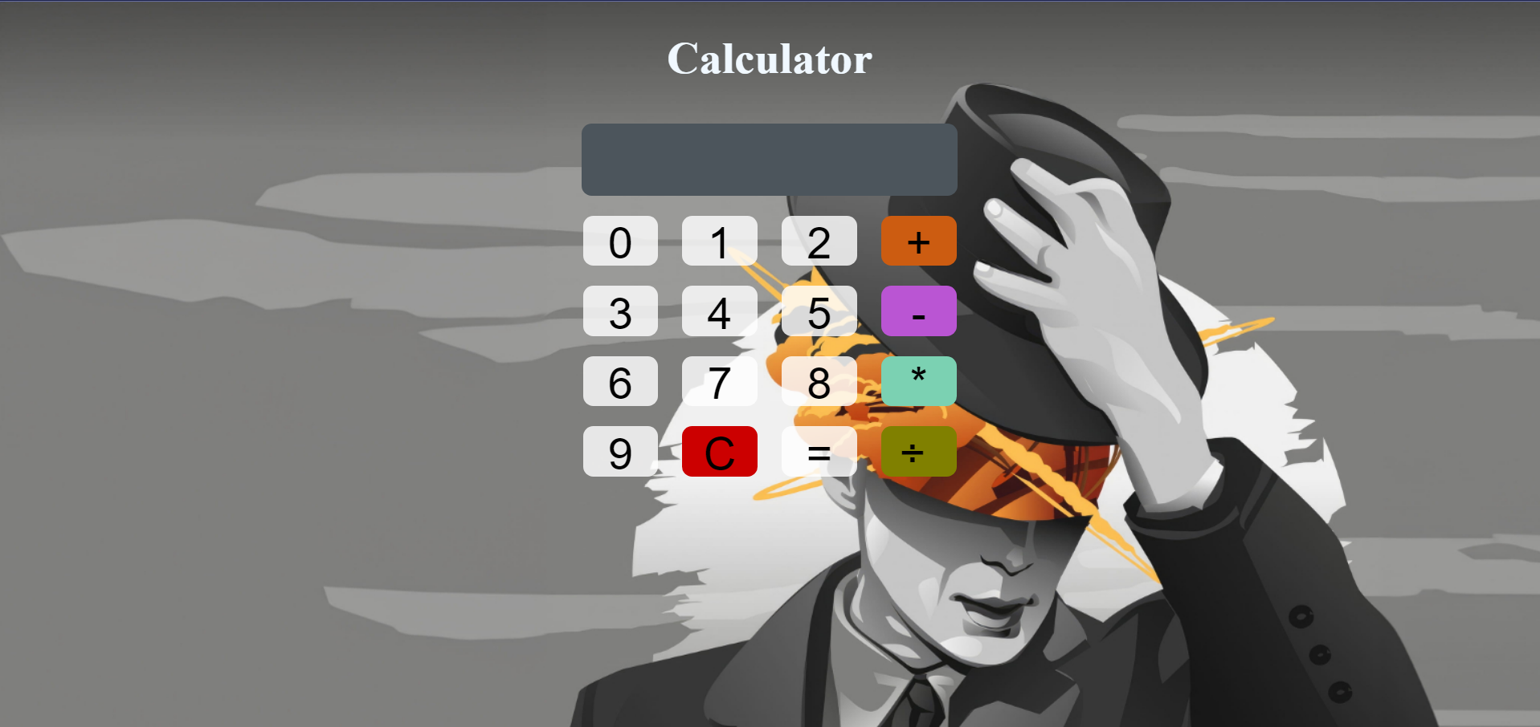

**Task No 2:**

**Task No 3:**

